EVAM CANBus 2.0 Reassembly Instructions
  - Last updated: 11 Feb 2025

Table of Contents
1 Setup Instructions 3
2 High Power Lines Installation 4
3 Motor Controllers' installation 6
4 Understanding the Master Cable 7
5 CAN Modules Installation (8 Modules in Total) 10
5.1 BMS CAN module installation (rear) 10
5.2 Motor CAN module installation (rear) 11
5.3 Motor CAN module installation (front) 12
5.4 Throttle CAN and Steering Angle modules installation (front) 12
5.5 HUD and ECU CAN modules installation (front) 14
5.6 CAN Bus Black Cables Connection to all nodes 15
6 E-stop connection 19
6.1 Battery Estop 19
6.2 Motor Estop 21

Version history
V1.0: First draft published 11 Feb 2025.

1 Setup Instructions
- Ensure that all high temperature works (e.g. Welding) on mainframe are completed before rewiring of car.
- Wiring can be done before the battery is placed back into the car. No need to install the battery first
- Remove the two seats (note that front seat has spacers for wires to run below, while the rear seat does not have spacers) to make room for wiring.
- If you need wiring guidance, please refer to the Wiring and Brake Overview Diagram PDF file.
CRITICAL WARNING
- Rewiring can be dangerous if improperly done! There is a genuine risk of fire and electrical shock if wiring is not done properly once the battery is connected. Always double/triple check your connections once completed.
- The chassis is grounded at a 0V potential. This means that any stray wire that accidentally contacts the chassis may cause a serious short circuit incident!
- Always double check that there are ZERO frayed wires and take note that some of the dashboard elements such as the Estop signals are 100V signals directly coming from the battery.
- There HAVE BEEN incidents where the 100V Estop signal inadvertently touched the chassis resulting in an electrical arc incident, which thankfully was brief and did not result in serious harm. DO NOT be the first casualty!

2 High Power Lines Installation
The high-power lines are responsible for conducting large currents from the battery to the motors.
Ensure that the bus bar panel is screwed into the blast plate. There should be a wire for grounding the chassis. Uncoil all overlapping/intersecting wires.
Below shows a picture of the components on the bus bar panels. Black high-power lines leading to the motor controllers are labelled front, rear, left and right. Replace the labels if they are missing or broken.
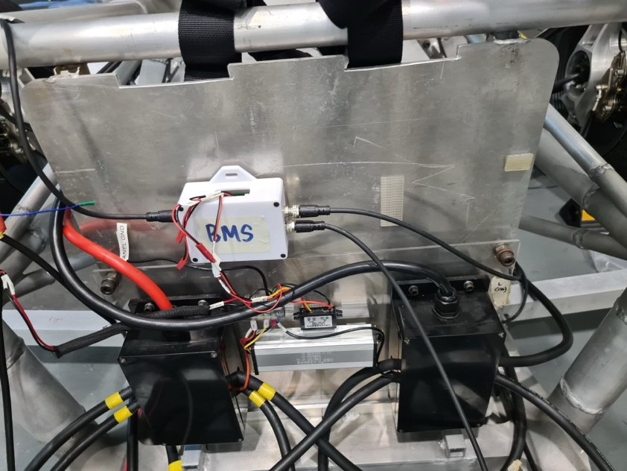
Figure 1: Bus bar panel mounted to the blast plate The BMS CAN module depicted in the picture is mounted later.
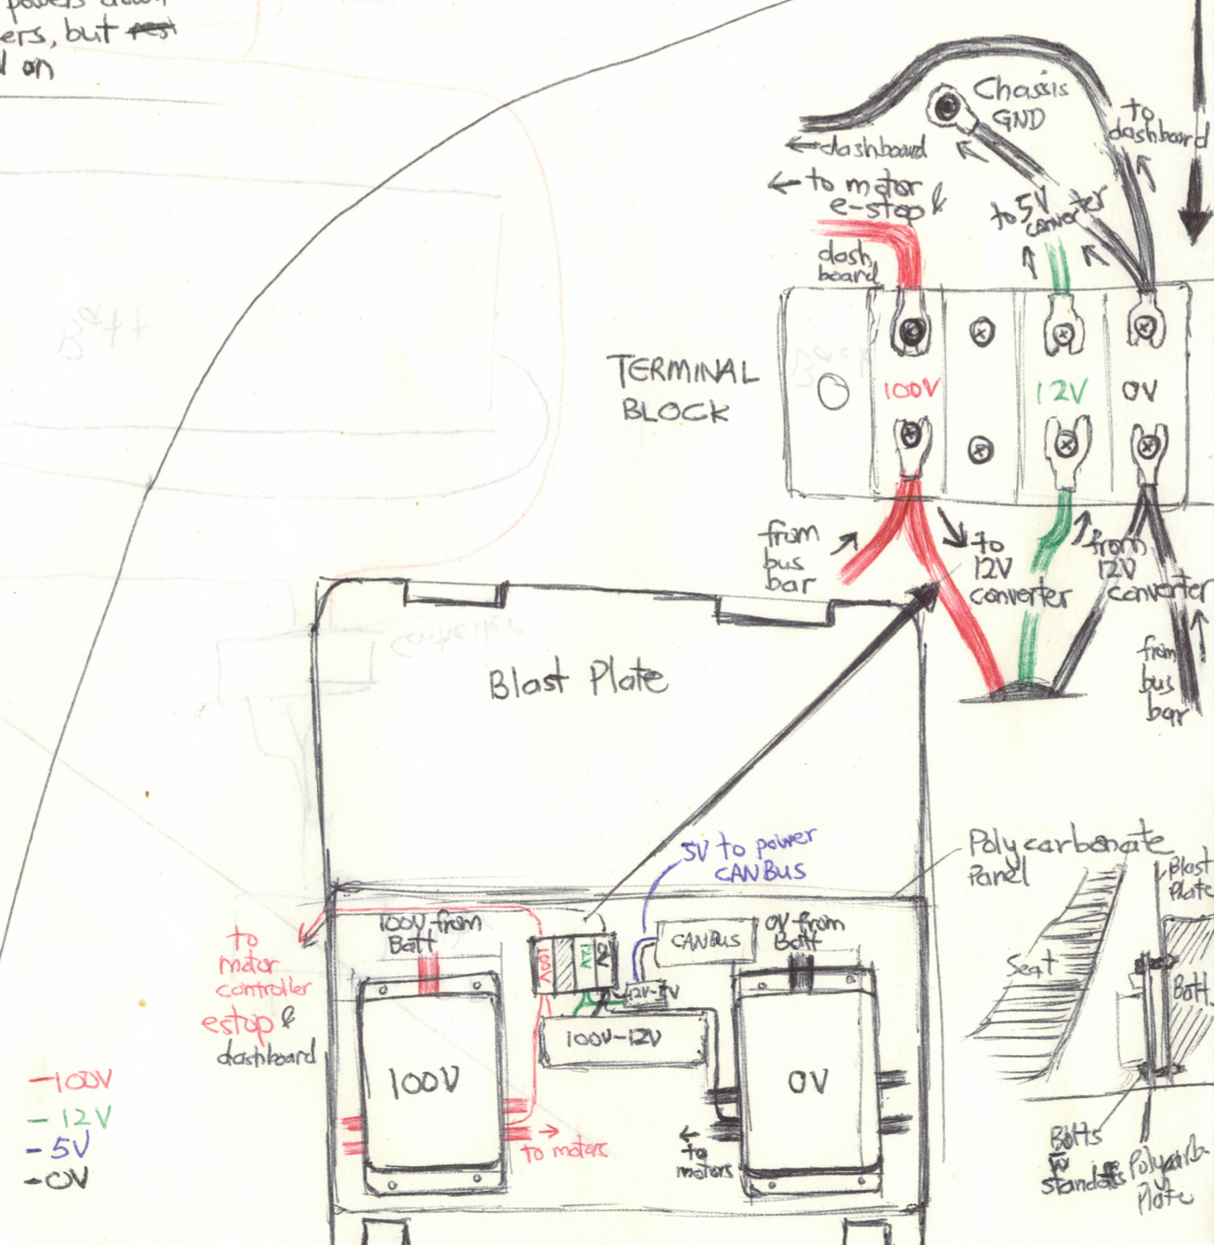
Figure 2: Diagram of the terminal block on the busbar panel
Within the busbar panel, there is a terminal block used to link some of the voltage lines together. This terminal block should eventually be replaced with something more robust.
The thin 100V lines serve 2 purposes: transport the 100V output directly from the battery to a 12V regulator to provide 12V electricals, and to provide the signal for motor Estop.
(insert wiring diagram on how cable is typically placed in the car)

3 Motor Controllers' installation
Attach motor controllers to main frame of car and wire the motors according to the color codes. Inspect all connectors and cables for motor controllers to ensure no wires are frayed.
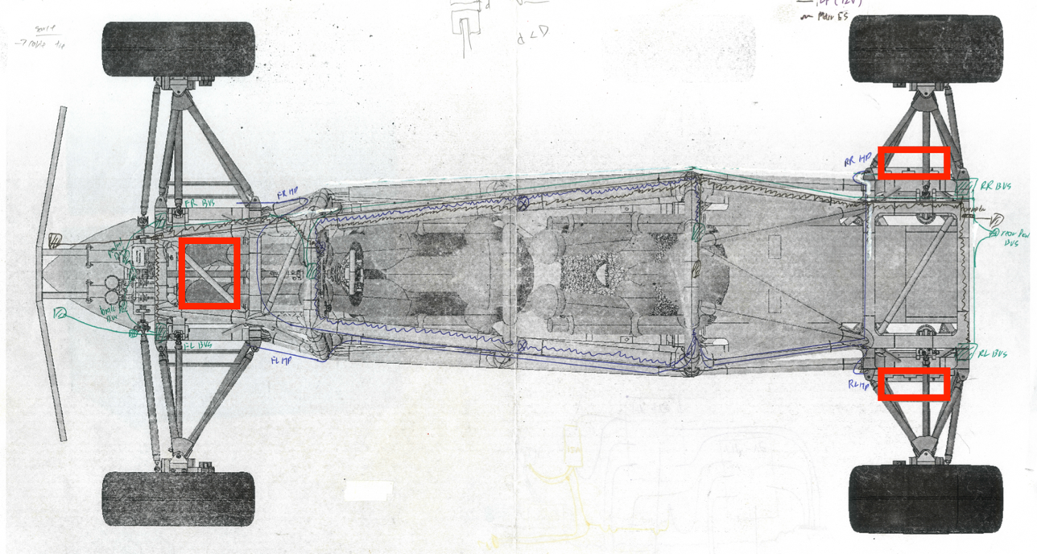
Figure 3: Motor controller locations
Motor controllers should be labelled appropriately with rear or front, as THEY HAVE DIFFERENT PINOUTS. Failure to maintain front/rear will result in failure of individual motor drivers.
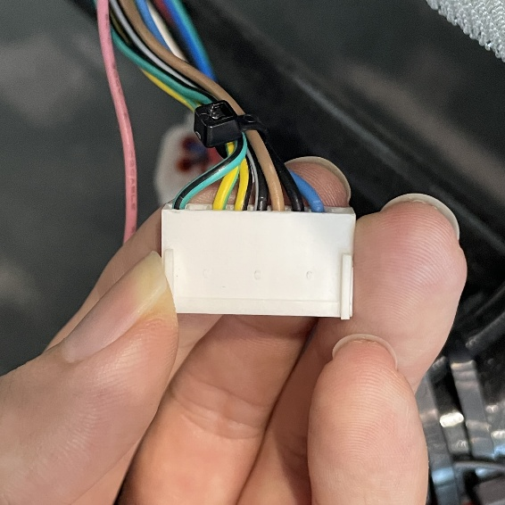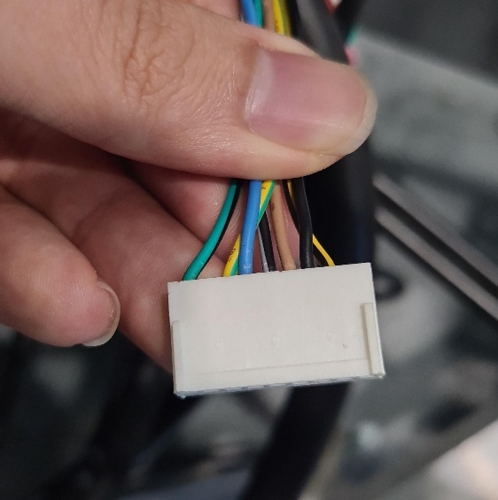
Figure 4 (left): example of a rear motor controller connector
Figure 5 (right): Example of a front motor controller
(insert picture on how to connect hall connector of motor controller to wheel hub motors)
(insert picture of high-power lines attached to motor controllers)

4 Understanding the Master Cable
The Master Cable is a specially made cable that runs the entire length of the vehicle, starting at the battery’s CAN connector and ends at the front dashboard, with a split in the middle to accommodate the battery Estop button in the middle of the vehicle.
This cable is designed to handle the following functions:
- Motor Estop
- Battery Estop
- Battery CAN bus
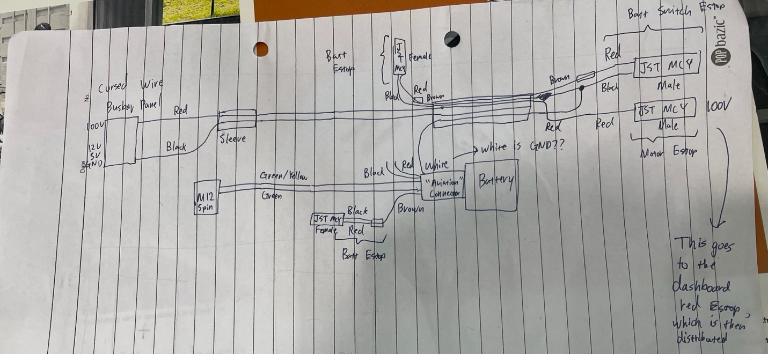
Figure 6: Basic hand drawn diagram of the Master Cable
The Master Cable should be replaced as soon as possible with a more professional solution as the bend radii of several inner cables are too short, potentially causing breakages and dangerous operating conditions.
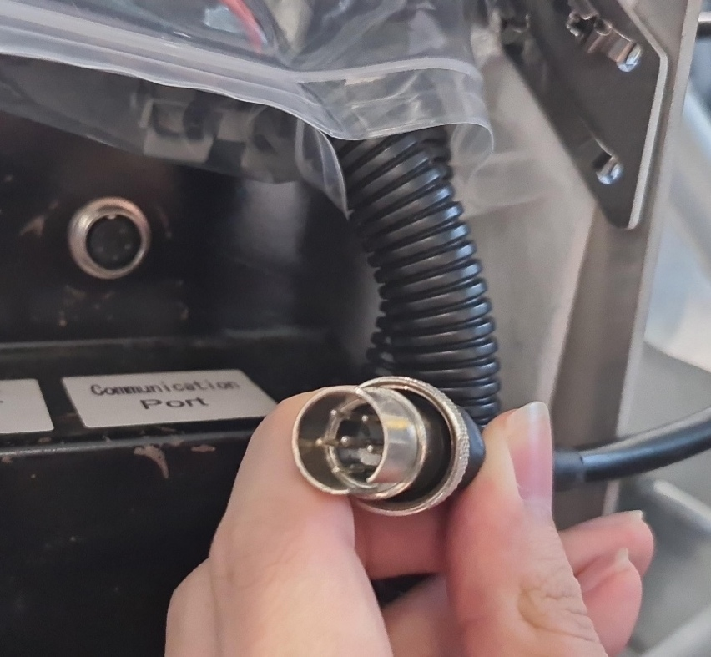
Figure 7: Battery CAN connector
The Master Cable chiefly contains the following signals stemming from the Battery CAN Connector (see above figure).
- Pin 5: CAN High
- Pin 6: CAN Low
- Pin 3: unknown red cable (possibly 100V)
- Pin 4: unknown black cable (possibly GND)
- Pin 1: battery estop switch
- Pin 2: battery switch

This bundle is then carried through the middle of the vehicle where it interfaces with the battery Estop switch:
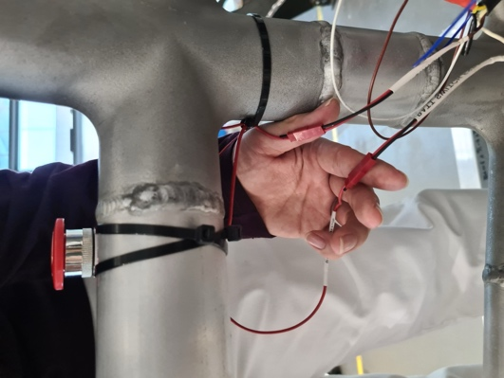
Figure 8: Battery Estop switch
After this, the bundle is split and additional cables travels to the front for the battery switch on the dashboard (turn knob).
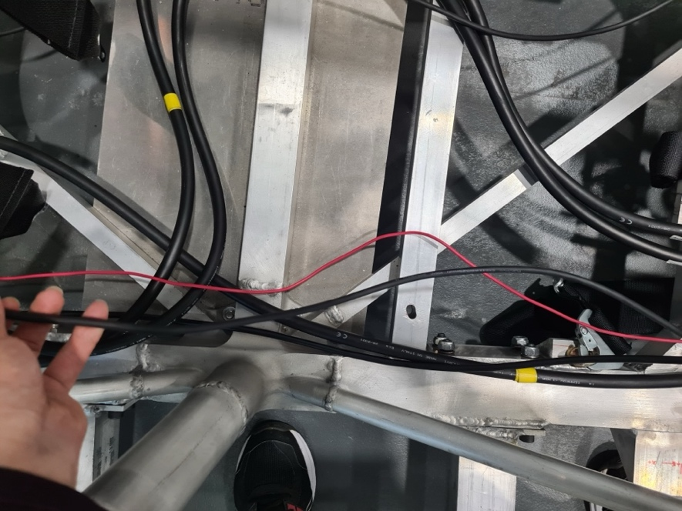
Figure 9: Black cable being held is the Master Cable as it travels from the middle Estop to the dashboard battery switch

5 CAN Modules Installation (8 Modules in Total)

5.1 BMS CAN module installation (rear)
Using a M2 Allen Key, unscrew the screws on the enclosures to access the PCB. Connect the wires through the holes found the enclosures and screw the lid back on.
Connect the 5V and 12V sense lines from the CAN bus panel to the BMS PCB.
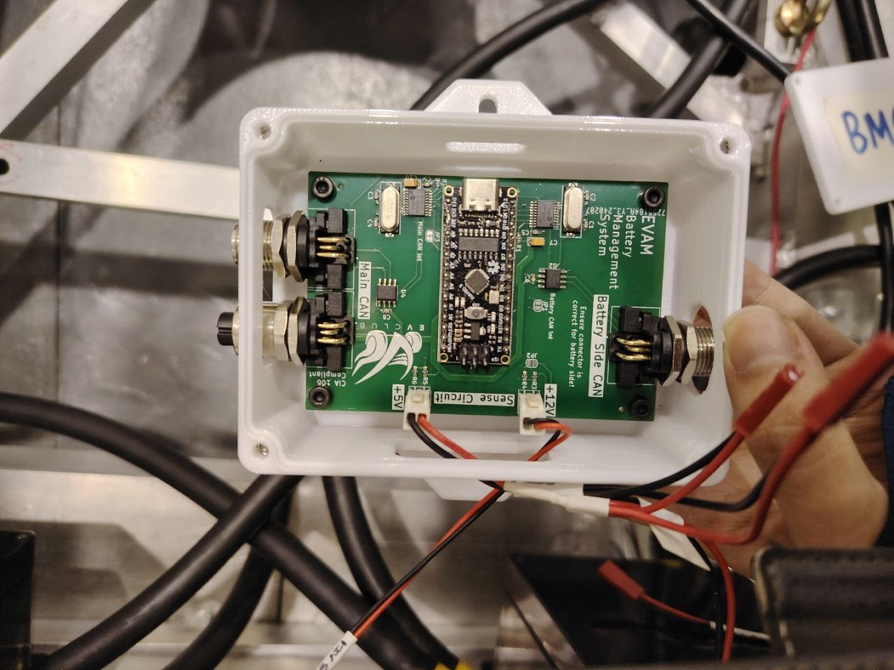
Figure 10: BMS CAN node wiring before attachment to bus bar panel
Attach the Battery Side CAN using the shortest M12 cable possible to the Master Cable’s battery connector, which runs to the battery’s internal system
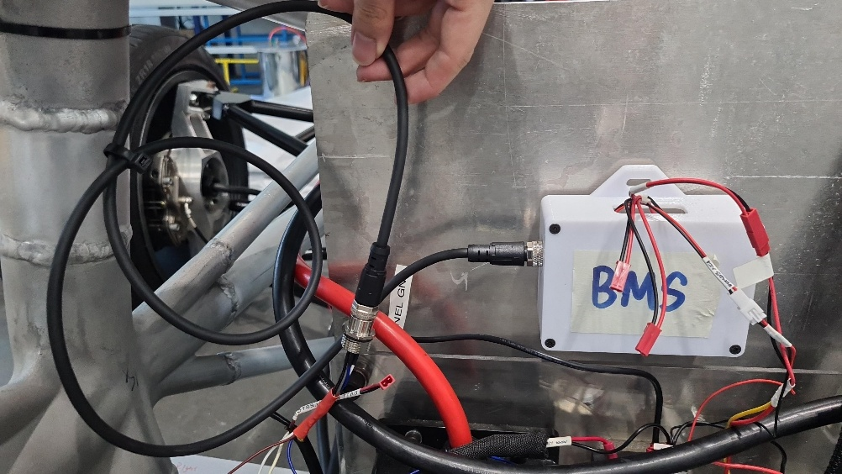
Figure 11: Connecting the BMS CAN port to the Master Cable

5.2 Motor CAN module installation (rear)
We will start with the motor node that has CAN termination, which has blackened corner marking on its top cover. This is installed on the rear left motor controller.
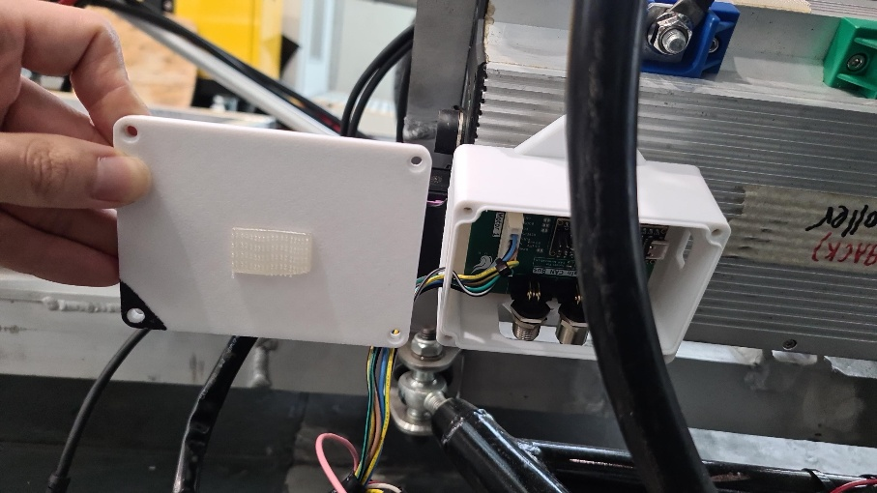
Figure 12: Rear left motor CAN node with black corner markings
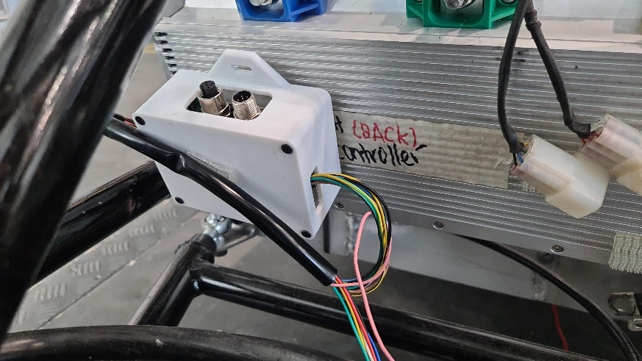
Figure 13: Rear right motor CAN node without markings

5.3 Motor CAN module installation (front)
The front of the vehicle has a dual motor CAN node. Connect both motor controllers to the CAN node and fasten them if necessary.
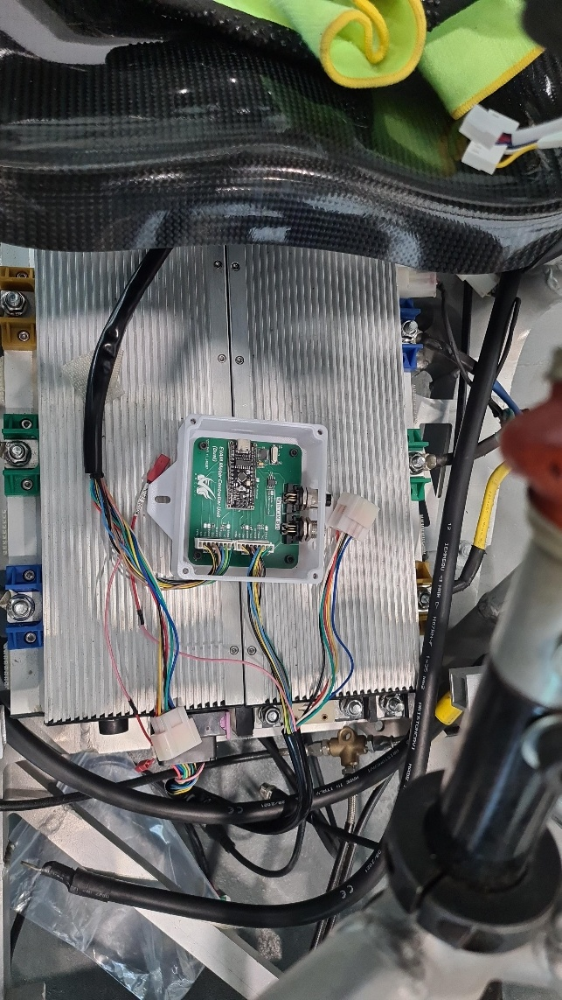
Figure 14: Mounting the Front Motor Controller

5.4 Throttle CAN and Steering Angle modules installation (front)
Attach the enclosures of the two modules to the front of the car near the brake and throttle pedals.
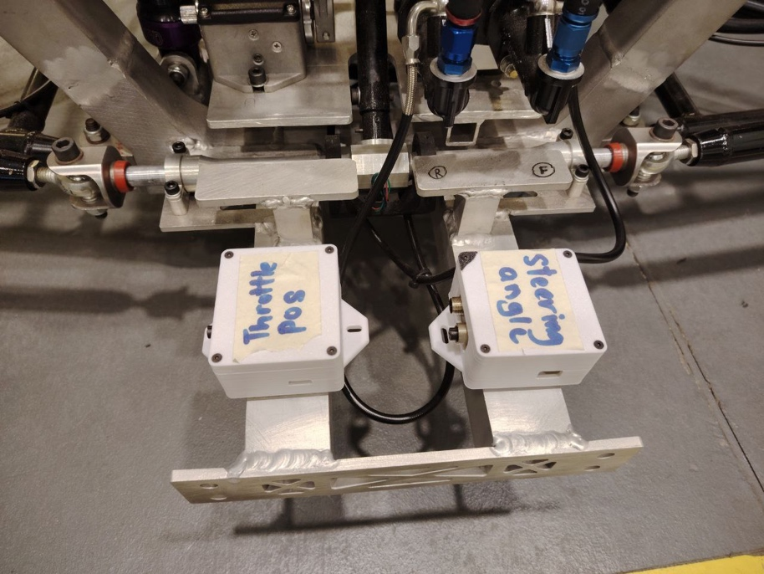
Figure 15: Placement of Throttle and Steering Angle Modules
Using a M2 Allen Key, unscrew the screws on the enclosures to access the PCB. Connect the wires through the holes found the enclosures and screw the lid back on.
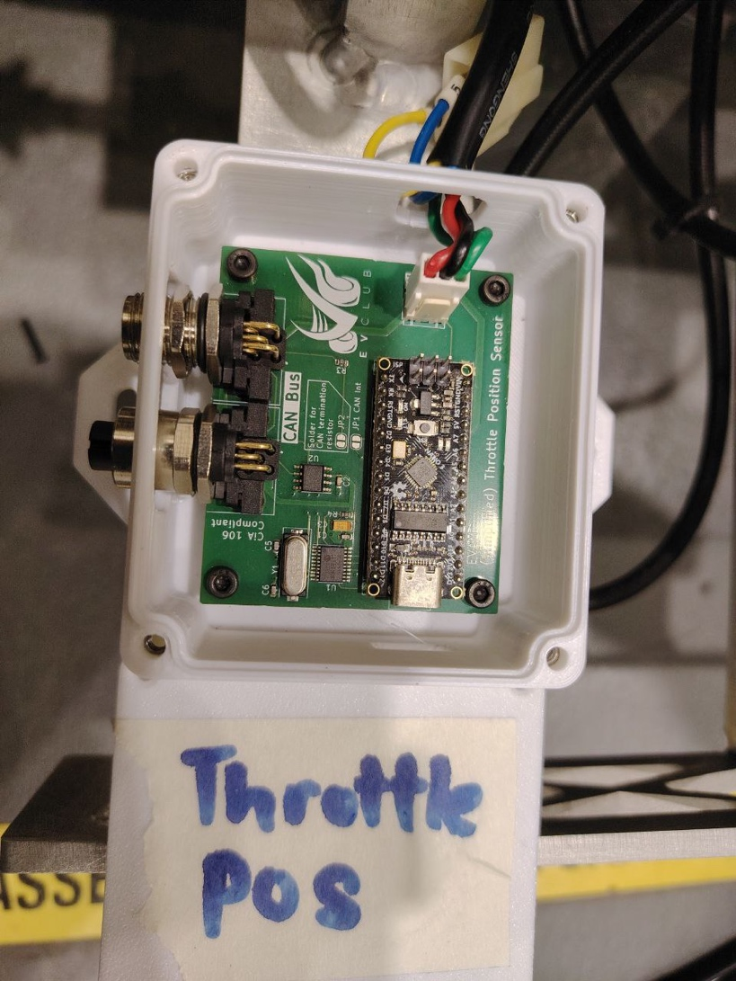
Figure 16: Throttle Position Sensor PCB wiring

5.5 HUD and ECU CAN modules installation (front)
Attach the enclosures of the two modules to the front of the car near the brake and throttle pedals. Wire up the HUD module appropriately according to the image below.
Take extra care to ensure that the right connectors are linked to the right sockets as the Estop is a 100V signal and WILL fry the module if connected incorrectly!!
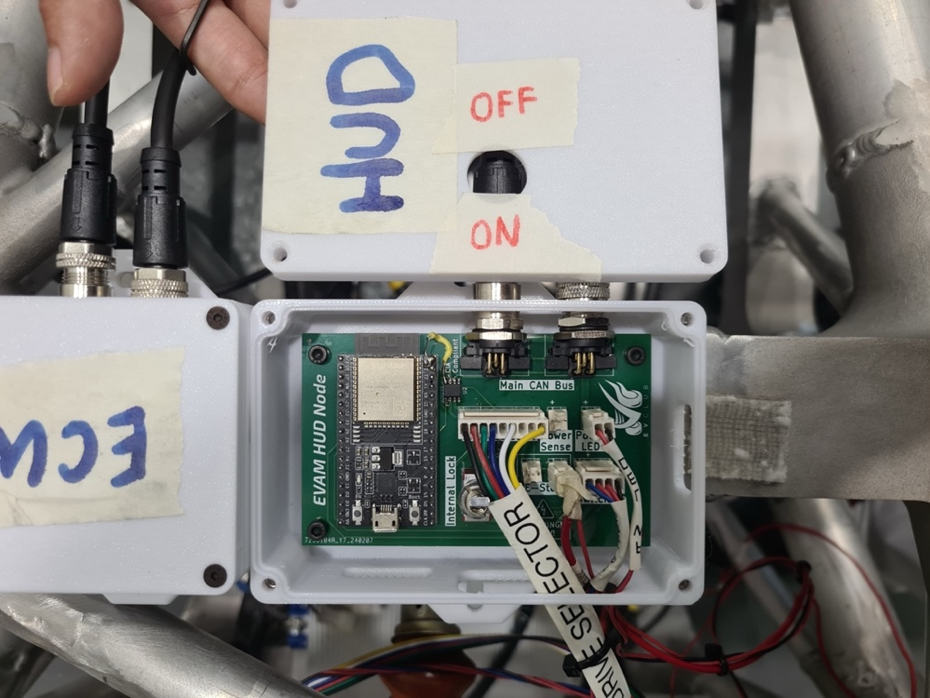
Figure 17: HUD PCB wiring. Note the masking taped wire is the high voltage Estop signal
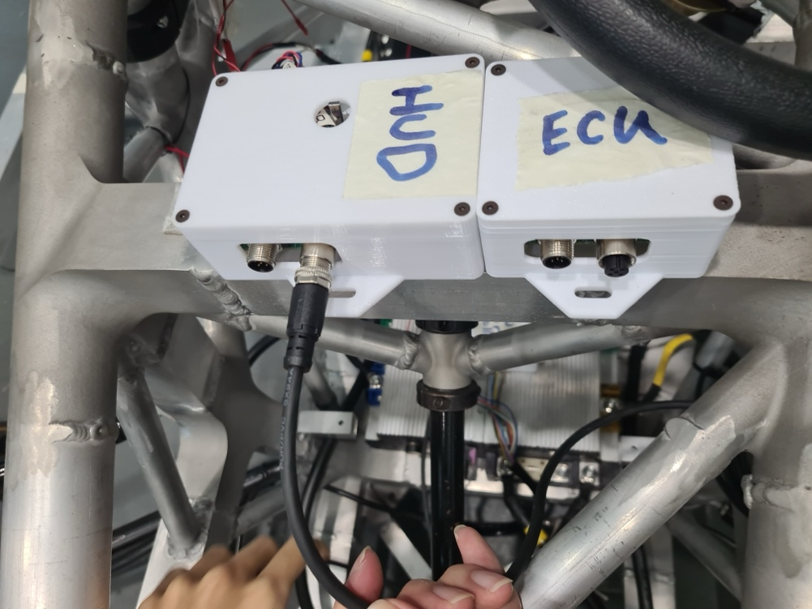
Figure 18: ECU and HUD module placements
Once this is complete, we can begin wiring up all the modules.

5.6 CAN Bus Black Cables Connection to all nodes
- Starting at the rear left motor node (which is a termination node, marked by the black edge colored by a marker), we run the cable to the rear right motor node.
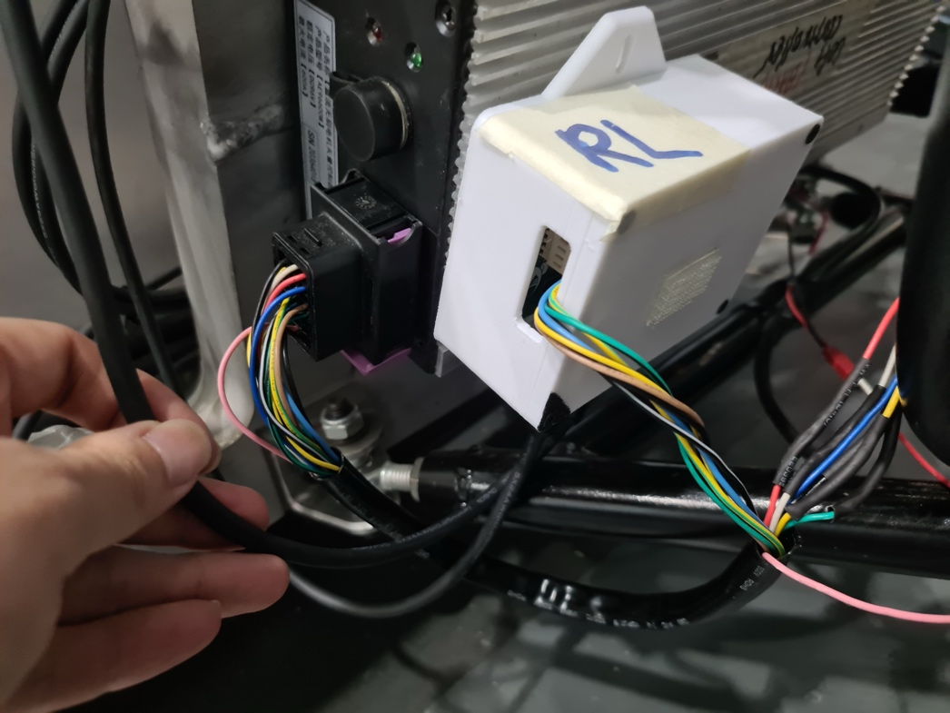
- Run the cable from the rear left motor node to the rear right motor node across the top of the vehicle
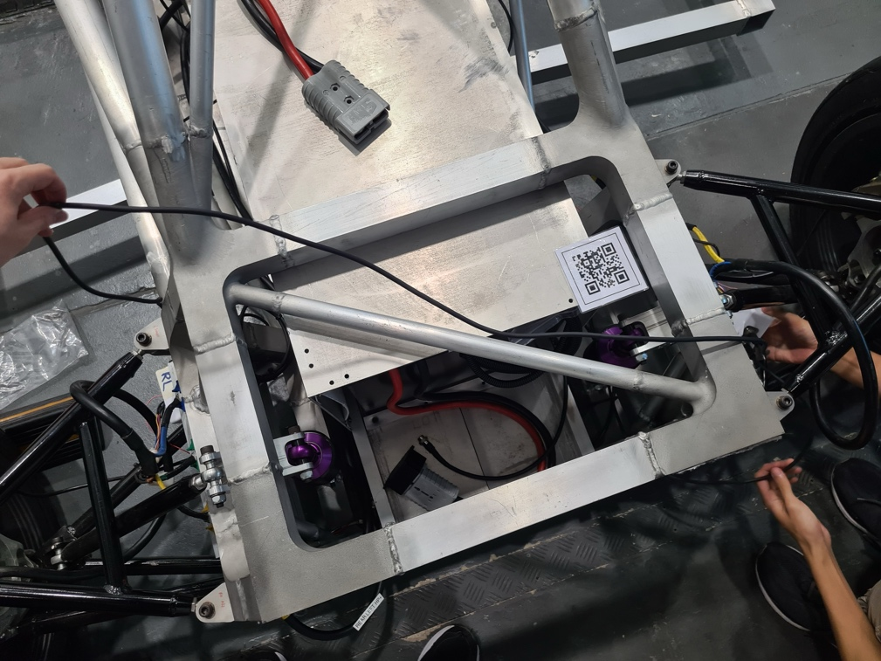
- Run a long cable from the right rear motor module to the front of the vehicle and connect it to the HUD node.
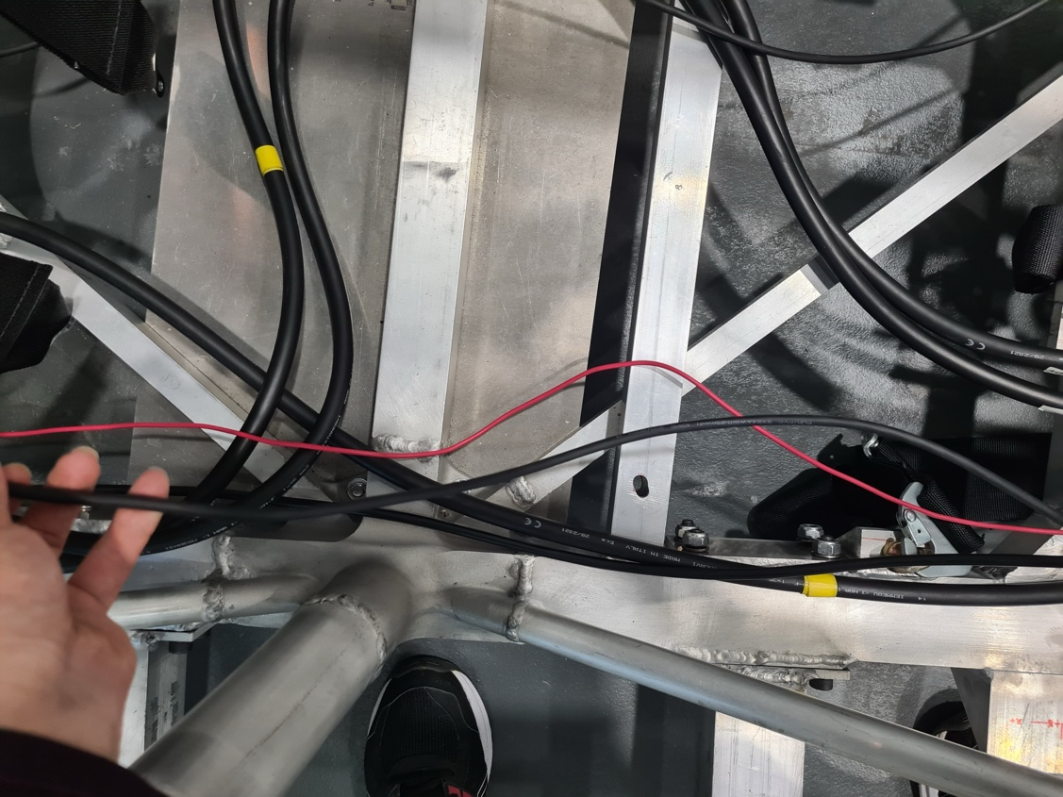
- Use the shortest possible cable to connect the HUD and ECU modules together.
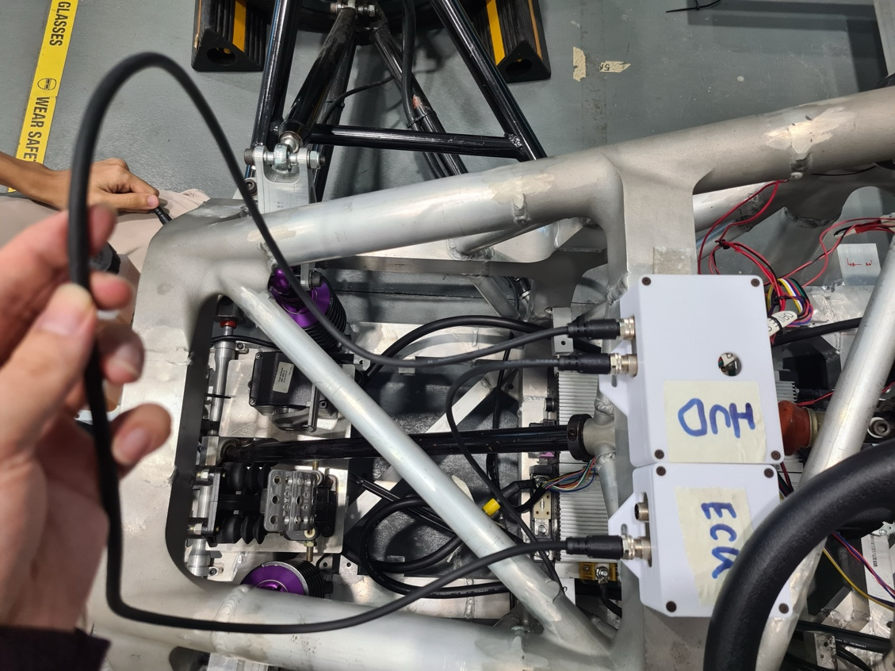
- Run the ECU cable to the throttle position sensor
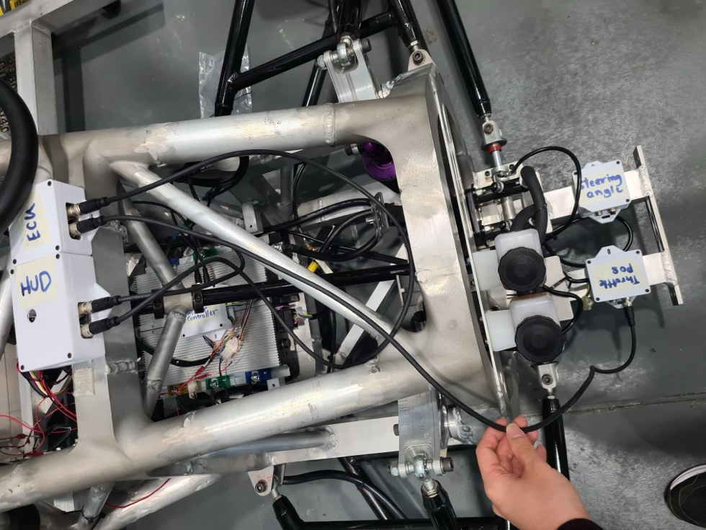
- Link the throttle position sensor and the steering angle sensor modules together.
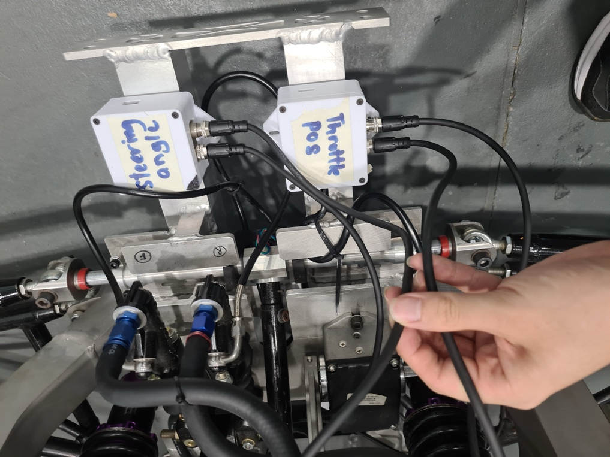
- Run another medium length cable from the steering angle sensor to the front dual motor module
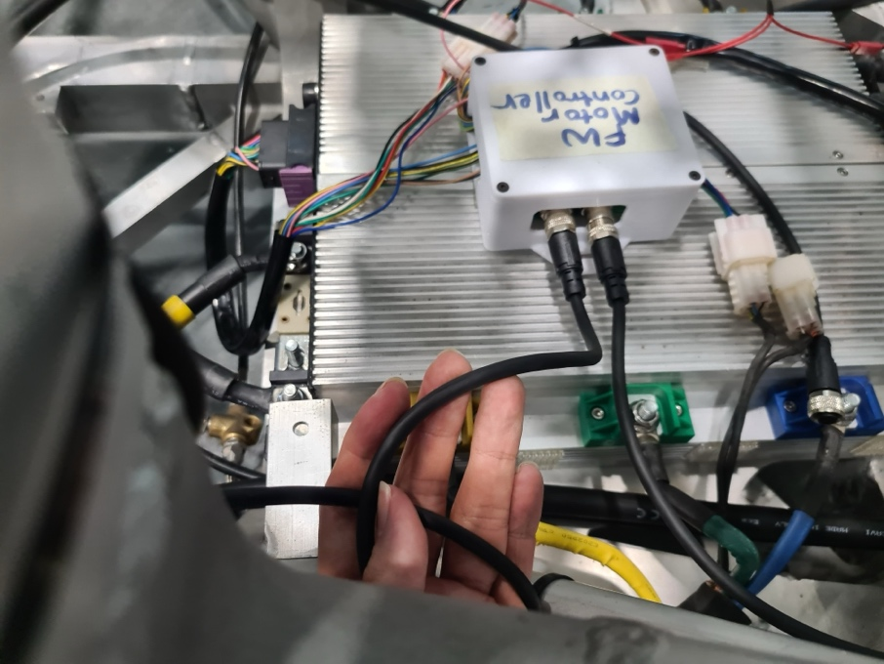
- Wire the front dual motor module to the battery management system module. Finally, wire the BMS module to the rear left motor module mentioned in the 1st step and the CAN bus wiring is complete!
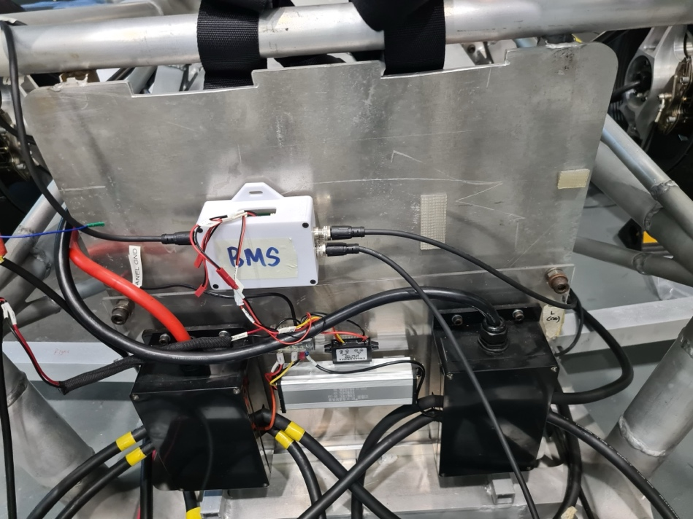

6 E-stop connection

6.1 Battery Estop
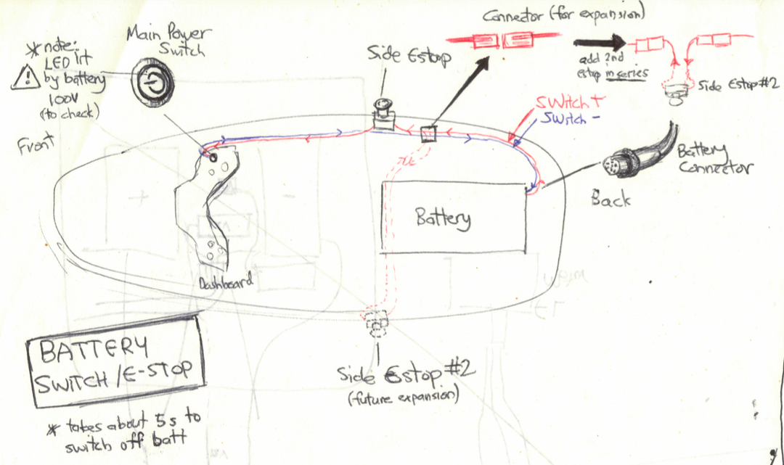
Figure 19: Battery E-stop diagram
The battery Estop system runs a single electrical signal in the following order:
- Battery Connector
- Estop button on the side of the vehicle
- Power switch on the front of the vehicle.
It is a relatively easy to install system as it only needs to connect at 3 points.

Figure 20: Rear of the Master Cable, which connects to the battery’s Communication Port
Once the Master Cable is installed into the vehicle (this is the cable that contains the battery signal connector, which is a proprietary “aviation style” connector instead of the standard M12 connector), the Estop button can be wired up as in the pictures below:
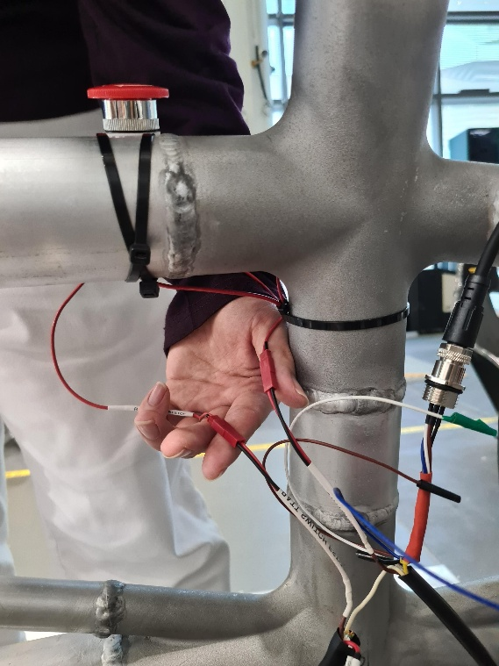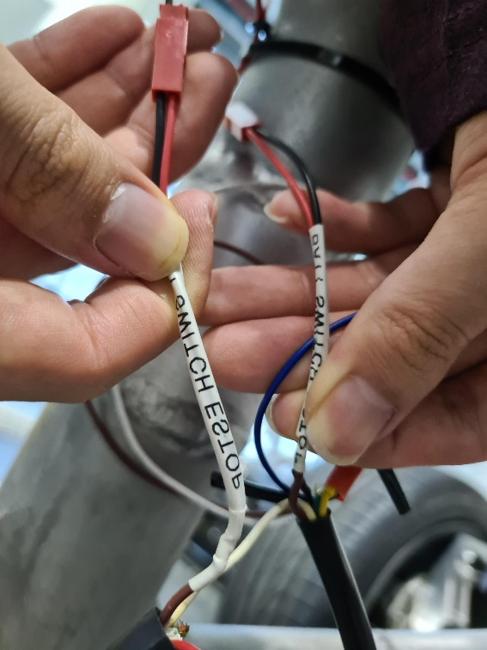
Figure 21 (left): Master Cable to Battery Estop switch on the side of the vehicle
Figure 22 (right): Master Cable to Battery Estop switch in the front of the vehicle
The red wire labelled ESTOP SWITCH must be wired to the front of the vehicle, where the red power switch is placed. The other wire labelled BATT ESTOP must be wired to the rear of the vehicle, where the battery’s signal cable is being plugged in.

6.2 Motor Estop
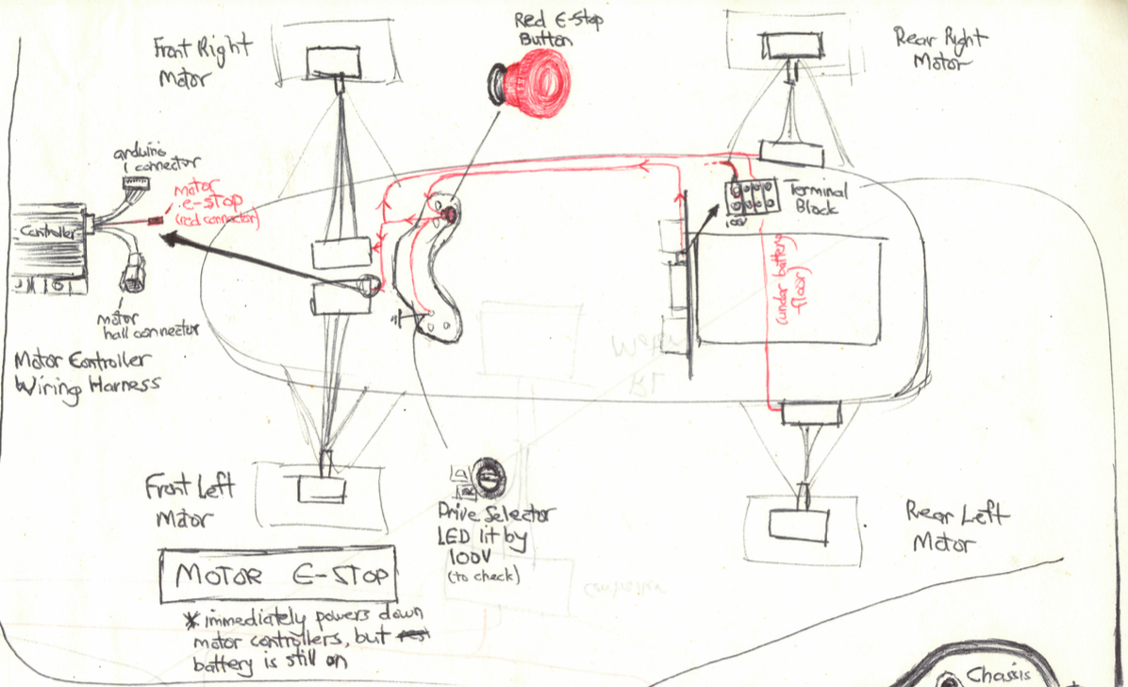
Figure 23: Motor Estop schematic
The Motor Estop is more complex, and is routed to the following places
- 100V from Terminal Block: This is where the 100V originates for the motor Estop signal
- Dashboard Estop button: root node, this button
- Front Left Motor Controller
- Front Right Motor Controller
- Rear Right Motor Controller
- Rear Left Motor Controller
The Motor Estop system is responsible for allowing the driver to assert a stop signal to all the motor controllers, allowing them to go into standby mode without having to power off the entire vehicle.
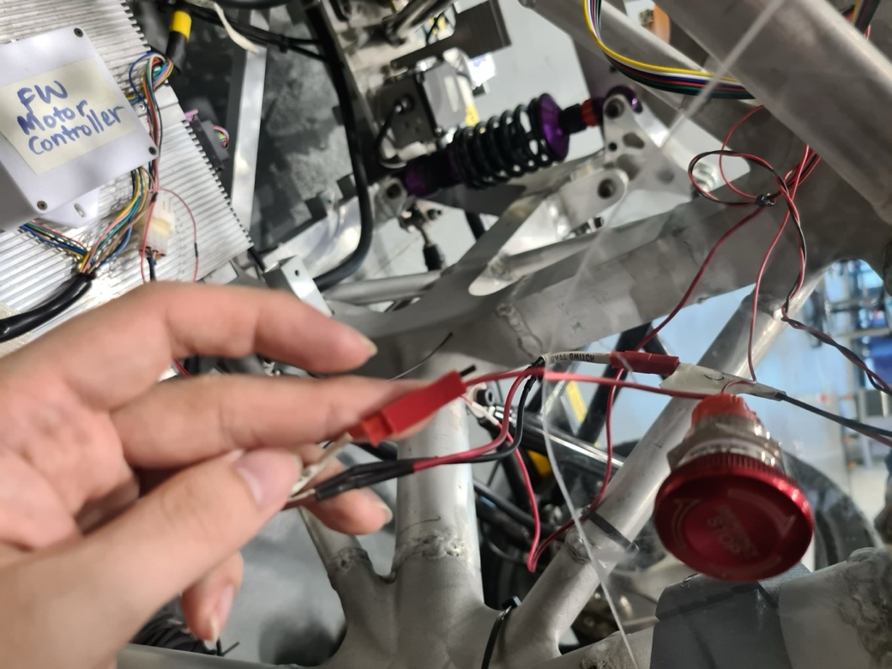
Figure 24: Front motor Estop button wiring
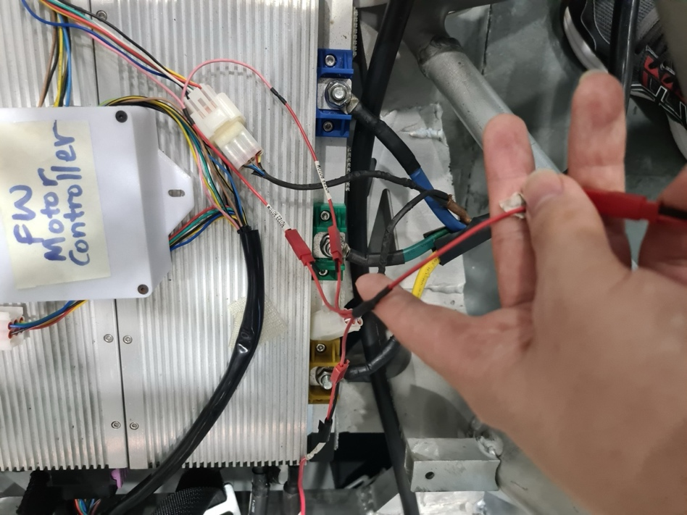
Figure 25: Front motor controllers wired to front Estop switch

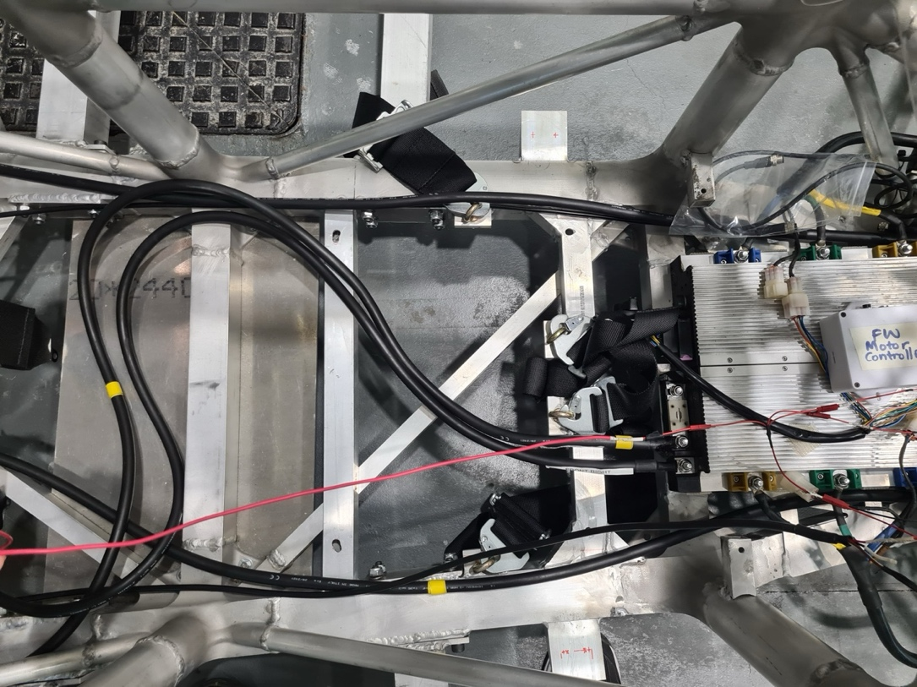
Figure 26: Red cable which conducts the Motor Estop signal going from the front controllers to the rear. Note the splice on the right side of this image
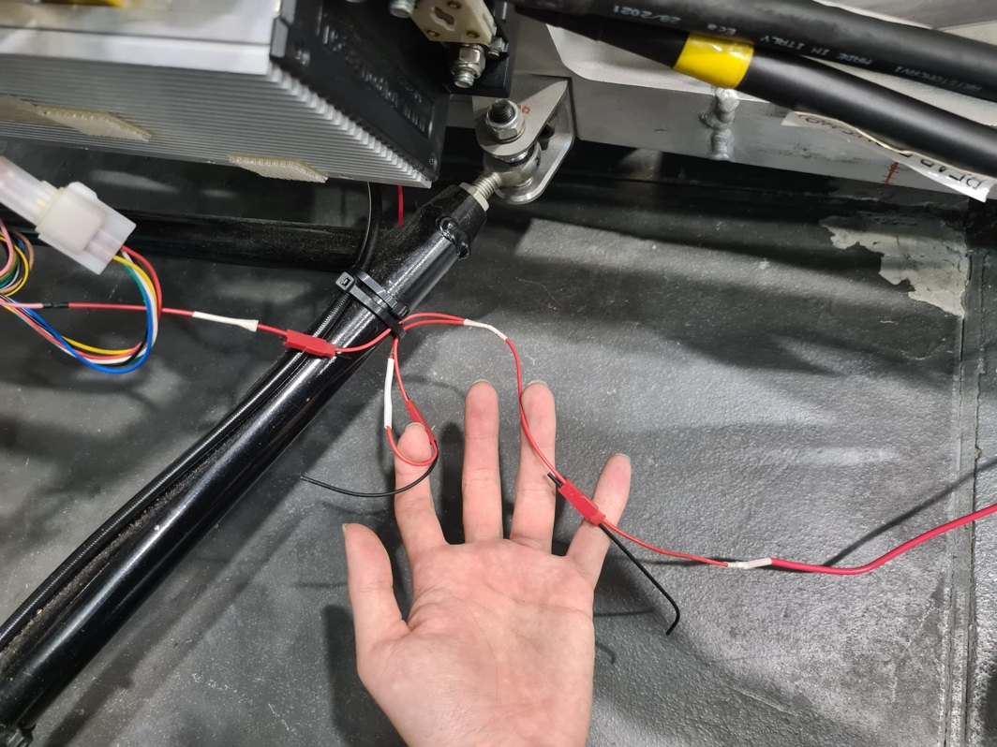
Figure 27: Motor Estop wire as it routes to the rear motor controllers, splitting at the right rear controller and proceeding to the left rear controller

